Story Structure Combo by Katie Knightley

Using: Save the Cat, Romancing the Beat, 4 Act Structure, Creating Character Arcs, Story Genius

**Road Map:**

**Opening -**

**Inciting Event -**

**Midpoint -**

**Lowest Point -**

**Climax -**

**Finale -**

* The 1st Act is about setting up your character’s Lie. The 2nd Act is about destroying the Lie & helping the character find the Truth that will allow them to combat the external conflict and grow into a whole person. Plan a First Plot Point that will tear away your character’s safety net and force them to step out into the biggest adventure of their life.
* *The 1st half of your book is about the character reacting to events and the 2nd half is about them taking action*

Subplots layer the story, and also have an arc/ending.

* **Subplot 1**
* **Subplot 2**
* **Subplot 3**

**PART I**

Scene 1: Opening Image; Intro MC & external goal with stakes

Scene 2: Set up; Theme Stated

Scene 3: Set up; Meet Cute

Scene 4: Set up; No Way #1

Scene 5: Catalyst; Adhesion

Scene 6: Debate

Scene 7: Debate

Scene 8: Break Into 2

**PART II**

Scene 9: B Story/Fun & Games; No Way #2

Scene 10: Fun & Games

Scene 11: Fun & Games; Inkling it could work

Scene 12: Fun & Games; Pinch Point #1 ~37.5% antag flexes

Scene 13: Fun & Games; Deepening Desire

Scene 14: Fun & Games

Scene 15: Fun & Games; Maybe this’ll work?

Scene 16: Midpoint

**PART III**

Scene 17: Bad Guys; Inkling of Doubt

Scene 18: Bad Guys; Deepening Doubt

Scene 19: Bad Guys; Retreat, Retreat!; Pinch Point #2 ~62.5% Antag, Ramps up Stakes, showcases final battle

Scene 20: Bad Guys; Shields Up

Scene 21: All is Lost; Break Up

Scene 22: Darkest Night

Scene 23: Darkest Night; Darkest Night

Scene 24: Break into 3; Wake Up, epiphanies, truths, start completing the character arc

**PART IV**

Scene 25: Finale - Gathering the Team; Grand Gesture

Scene 26: Finale - Executing the Plan; Grand Gesture

Scene 27: Finale - Hightower Surprise; Grand Gesture

Scene 28: Finale - Dig Deep Down; Grand Gesture; fully reject the lie & embrace the truth. Complete the character arc.

Scene 29: Finale - Execution of the New Plan; Grand Gesture

Scene 30: Final Image; Whole Hearted

As you approach each scene, gather everything you know about your protag and their subjective worldview at the moment. What’re they most worried about? How will that affect their judgment in this scene?

Zero in on the heart of the story, and take out the real-life distractions that don’t affect it, and weave in relevant elements.

Our brains follow an ‘if this, then that’ process. A story follows a cause and effect trajectory from start to finish. Action-Reaction-Decision

No matter how much something catches you off guard, nothing ever really occurs out of the blue.

Plot-wise cause and effect plays out on the surface level, as one effect logistically triggers the next. (The plot = External events)

Story-wise cause and effect plays out on a deeper level—that of meaning. (Protag’s internal struggle = the story)

The WHY is the cause, the WHAT is the effect.

There’s an external and internal cause and effect.

*Myth: Show, Don’t Tell is literal - Don’t tell me John is sad, show him crying.

*Reality: Show, Don’t Tell is figurative - Don’t tell me John is sad, show my WHY he’s sad.

Show a character’s train of thought, internalization.

Competing desires, fears, and therefore choices.

Every action has a cause and consequence.

Every scene must:

-In some way be caused by the ‘decision’ made in the scene that preceded it

-Move the story forward via the characters’ reaction to what is happening

-Make the scene that follows it inevitable

-Provide insight into the characters that enables us to grasp the motive behind their actions.

You can ask yourself these questions for cause and effect:

-Does this scene impart a crucial piece of information, without which some future scene won’t make sense?

-Does it have a clear cause the reader can see (even if the ‘real reason’ it happened will be revealed later?

-Does it provide insight into why the characters acted as they did?

-Does it raise the reader’s expectation of specific, imminent action?

Ask yourself - if I cut it out, would anything that happens afterward change?

Does it pass the ‘and so?’ Test. What’s the point? How does it further the story? What consequence does it lead to?

Story Structure Combo by Katie Knightley

Background on Characters, World, Story Arc, Etc

**WIP TITLE:**

POV, tense,

Theme:

Story Arc:

**Main Character:**

Backstory on why they are the way they are -

Flaw -

Wound -

Misconception about love -

Lie -

Want -

Need -

Appearance -

Worldview -

Family life -

Personality -

Voice -

Favorites -

Arc -

All your secondary characters think they’re the main character and have their own agenda, realizations, and often their own arc. When you create them and their agenda, keep in mind how they’ll help facilitate your protag’s story.

Create a bio for each significant secondary character, keeping it story specific.

Ask yourself, how will this character’s agenda fit into the story I’m going to tell? This character will either challenge or reaffirm your protag’s misbelief. Write down what they might open your protag’s eyes to.

**Love Interest:**

Backstory on why they are the way they are -

Flaw -

Wound -

Misconception about love -

Lie -

Want -

Need -

Appearance -

Worldview -

Family life -

Personality -

Voice -

Favorites -

Arc -

**Antag:**

Backstory on why they are the way they are -

Lie -

Want -

Need -

Appearance -

Worldview -

Family life -

Personality -

Voice -

Favorites -

Arc -

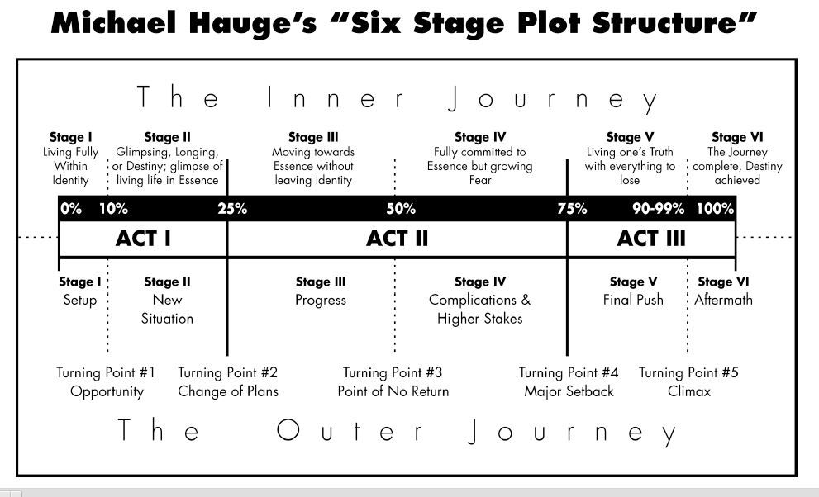

<https://writershelpingwriters.net/2018/08/the-six-stages-of-your-heros-character-arc/>

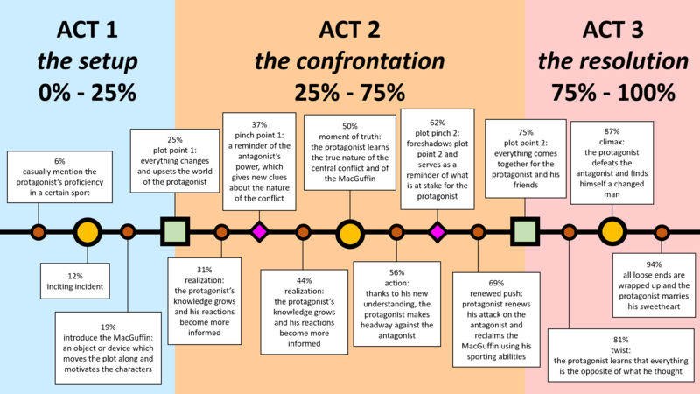

Character Arcs: Creating Character Arcs (K.M. Weiland) - <https://bit.ly/2n3QSfD>

Goal, Motivation, and Conflict (Debra Dixon) - <https://bit.ly/2FgKicp>

Writer’s Guide to Heroes and Heroines (Cowden) - <https://amzn.to/2OX54Fh>

Plotting and Story Arcs: Super Structure (James Scott Bell) - <https://bit.ly/2HI3d2g>

Screenwriting Tricks for Authors (Alexandra Sokoloff) - <https://bit.ly/2O6oOns>

Save The Cat Writes A Novel (Brody) - <https://amzn.to/39GeA9z>

The Seven Basic Plots (Booker) - <https://amzn.to/3f3uawG>

Structuring Your Novel (K.M. Weiland) - <https://bit.ly/2n3QSfD>

Worldbuilding: Worldbuilding Plan - <https://www.storyplanner.com/story/plan/world-buildingdetailed-plan>

Tools for worldbuilding online - <https://www.worldanvil.com/>

Map Making Online - <https://inkarnate.com>